LESSON 1 A2+ TUESDAY 19HS

* FIRST DAY SLIDES
* REVISION A2 LEVEL

**SPELLING EXERCISES:**

<https://www.liveworksheets.com/w/en/english-second-language-esl/1882146>

<https://www.liveworksheets.com/w/en/english-language/2019274>

<https://www.liveworksheets.com/w/en/english-second-language-esl/1375742>

**INTRODUCE YOURSELF:**

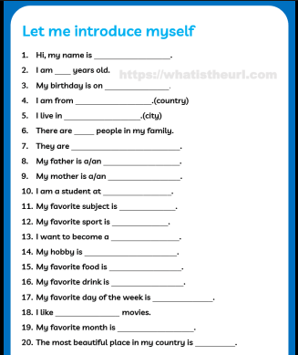

What’s your first name? [My first name is _____.]

What’s your last name? [My last name (AmE) is _____.] SURNAME (BrE)

What country do you live in? [I live in _____.]

What city do you live in? [I live in _____.]

Where did you live ten years ago? [Ten years ago, I lived in _____.]

What time do you usually get up in the morning? [I usually get up at_____.]

Do you have any brothers or sisters? [Yes, I do. / No, I don’t.]

What do you do? [I’m a _____.]

Do you work in a company? [Yes, I do. / No, I don’t.]

Do you speak Spanish? [Yes, I do. / No, I don’t.]

What do you like to do on the weekends? [On the weekends, I like to _____.]

What did you do last weekend? [Last weekend, I _____.]

What are you going to do next weekend? [Next weekend, I’m going to_____.]

What’s your favorite sport? [My favorite sport is _____.]

Do you know how to play tennis? [Yes, I do. / No, I don’t.]

What’s your favorite food? [My favorite food is _____.]

What food do you NOT like? [I don’t like _____.]

Where did you go on your last trip? [I went to _____.]

Where would you like to go on your next vacation? [I’d like to go to _____.]

What do you usually do in the evening? [In the evening, I usually _____.]

What are you doing now?

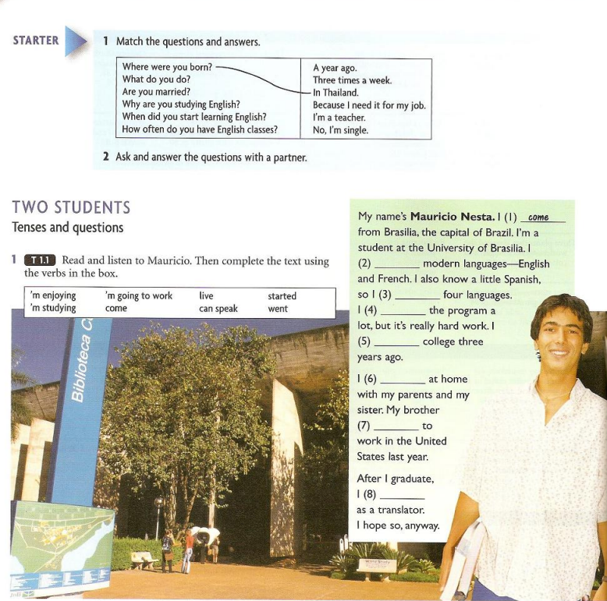

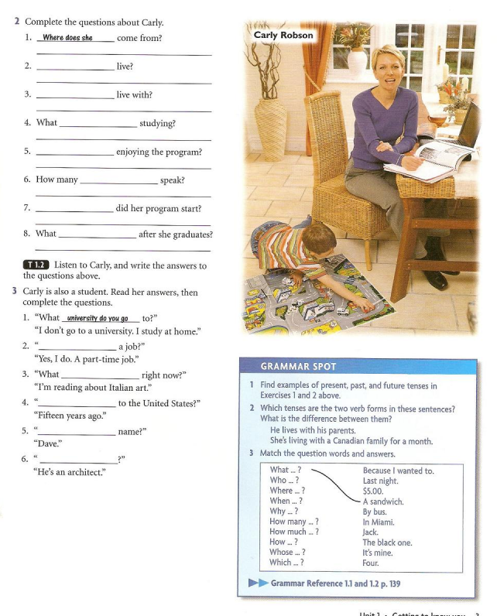

**SIMPLE PRESENT:**

[**https://www.liveworksheets.com/w/en/english-second-language-esl/93567**](https://www.liveworksheets.com/w/en/english-second-language-esl/93567)

[**https://www.liveworksheets.com/es/w/en/english-second-language-esl/209039**](https://www.liveworksheets.com/es/w/en/english-second-language-esl/209039)

**SIMPLE PAST:**

[**https://www.liveworksheets.com/w/en/english-second-language-esl/1070912**](https://www.liveworksheets.com/w/en/english-second-language-esl/1070912)

[**https://www.liveworksheets.com/w/en/english-second-language-esl/212806**](https://www.liveworksheets.com/w/en/english-second-language-esl/212806)

[**https://www.liveworksheets.com/w/en/english-second-language-esl/1849617**](https://www.liveworksheets.com/w/en/english-second-language-esl/1849617)

**FUTURE GOING TO:**

[**https://www.liveworksheets.com/w/en/english-second-language-esl/1494538**](https://www.liveworksheets.com/w/en/english-second-language-esl/1494538)

[**https://www.liveworksheets.com/node/6010841**](https://www.liveworksheets.com/node/6010841)

**Main Activity 1: Weekends**

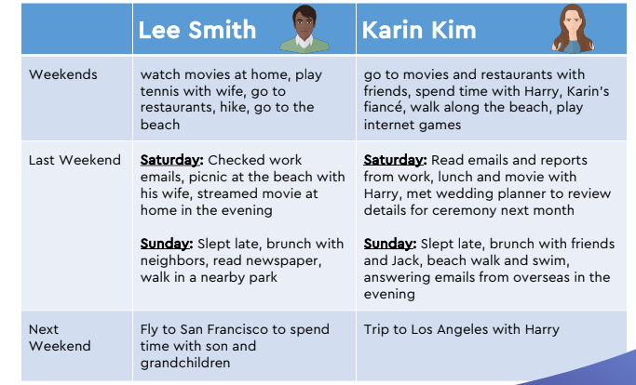

2. Point at the table and say: Here you can see information about the weekend activities of Lee Smith and Karin Kim. They work at the same company. The table has information about what they usually do on the weekends, what they did last weekend, and what they are going to do next weekend.

“brunch”, “fiancé”, “wedding”, “ceremony”, “streamed a movie”, or “hike.” BOTH

**ANSWER THE FOLLOWING QUESTIONS:**

Who is getting married? Lee

Who goes to movies with friends on the weekends? Karin

Who plays tennis? Lee

Who likes to go to the beach?

Who likes to go to restaurants?

Who is married?

Who is going to get married next month?

Who did some work last weekend?

Who plays games on the internet?

Who slept late last Sunday?

Who answered emails last Sunday evening?

Who walked in a park last Sunday?

Who went to the beach on Sunday?

Whose parents live in San Francisco?

Who is going to Los Angeles next weekend?

Whose fiancé is named Harry?

Who is going to San Francisco next weekend?

Who met with a wedding planner last weekend?

Who had brunch with neighbors on Sunday?

**WHAT ABOUT YOU?**

What do YOU usually or often do on weekends? What did YOU do last weekend?

I USUALLY SLEEP AND PLAY TENNIS ON WEEKENDS. THE LAST WEEKEND I CAME BACK HOME, BECAUSE I WAS ON HOLIDAY

What are YOU going to do next weekend?

I AM GOING TO PLAY A TENNI´S TOURNAMENT IN THE CLUB, AND I´M GOING TO MEET WICHT MY FRIENDS

**Main Activity 2: Transportation**

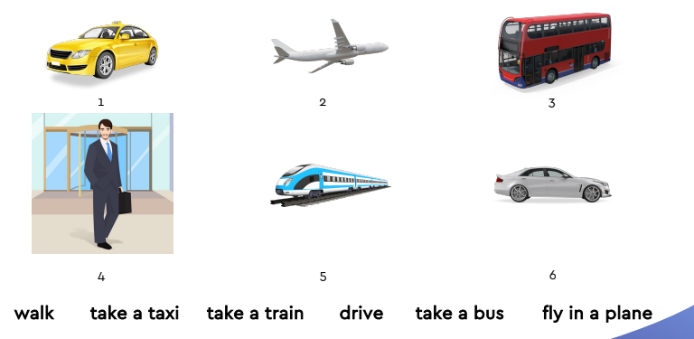

1. TAKE A TAXI
2. FLY IN A PLANE
3. TAKE A BUS
4. WALK
5. TAKE A TRAIN
6. DRIVE.

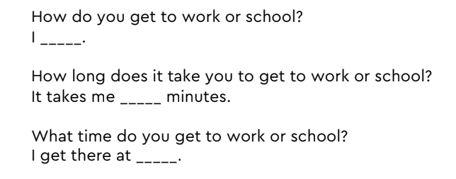

HOW DO YOU GET TO WORK?

I GET TO WORK BY CAR. I DRIVE TO WORK.

I TAKE A BUS.

HOW LONG DOES IT TAKE YOU TO GET TO WORK?

IT TAKE ME 30 MINUTES.

WHAT TIME DO YOU GET TO WORK?

I GET THERE AT 8.30.

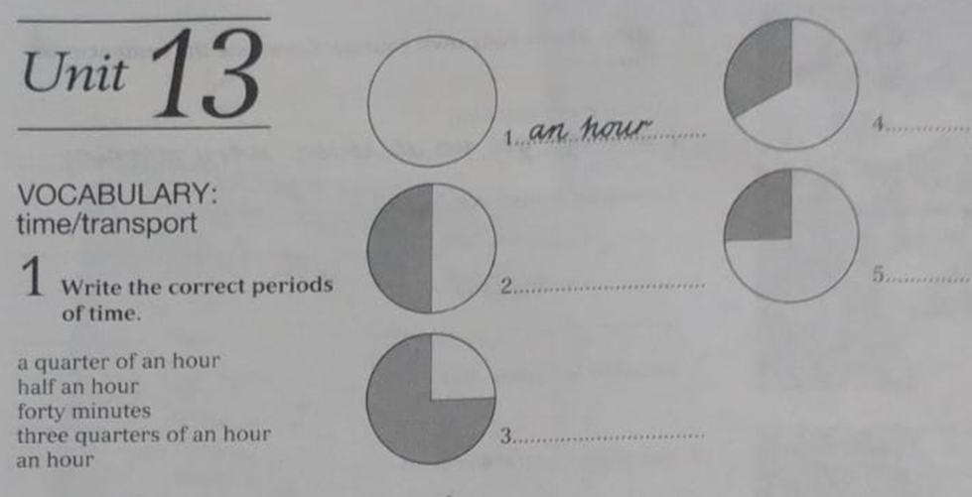

1. AN HOUR.
2. HALF AN HOUR
3. A QUARTER OF AN HOUR
4. FORTY MINUTES
5. THREE QUARTER OF AN HOUR.

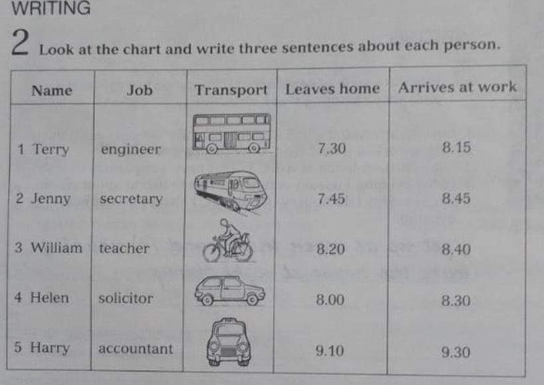

1. TERRY IS AN ENGINEER, HE TAKES A BUS TO WORK, HE LEAVES HOME AT 7:30 AND HE GETS TO WORK AT 8:15. He takes 45 min to get to work.
2. Jenny IS A SECRETARY, SHE TAKES A TRAIN TO OFFICE, SHE LEAVES HOME AT 7:45 AND IT TAKES HER ONE HOUR TO GET TO WORK / she gets to work at 8:45
3. WILLIAM IS A TEACHER, HE GETS TO WORK BY BIKE, SHE LEVAES HOME AT 8:20 AND SHE gets to work at 8:40. / IT TAKES him 20 MINUTES TO GET TO WORK /
4. HELEN IS A SOLICITOR, SHE DRIVES HER CAR TO WORK, SHE LEAVES HOME AL 8:00, AND SHE GETS TO WORK AT 8:30. / IT takes her 30 min to get to work.
5. HARRY IS AN ACCOUNTANT, HE TAKES A TAXI TO WORK, HE LEVAES HOME AT 9:10, AND HE GETS TO WORK AT 9:30. / IT TAKES him 20 MINUTES TO GET TO WORK.

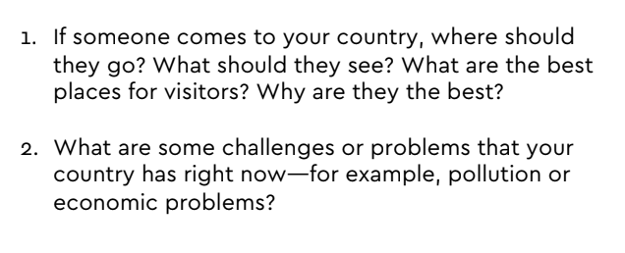

If someone you comes to my country , you should go to bs as, where you can see the obelisco and the pink house, buenos auires is a hot city and it has a lot monuments with history. Also in Argentina you could visitor the Iguazu waterfalls, is on the northeast of country, there are an amazing forest and different animals. The best place for visitors is Perito Moreno on the south, where you can eat asado and you could see a beautiful landscape.

In argentina you should drink mate, this is a typical drink .

Now

In my country the main problem is the economic, all is very expensive and people cant buy anything

SHOULD

CAN

COULD

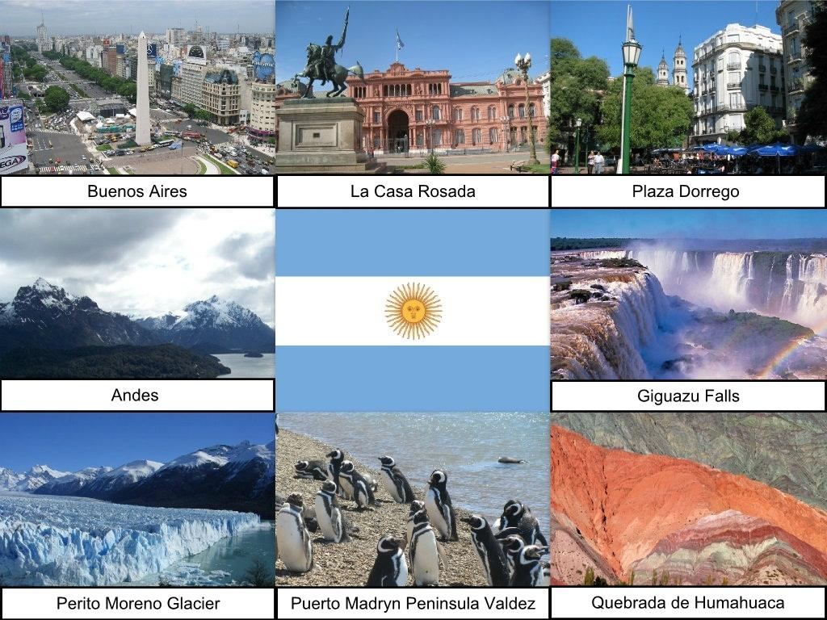

ARGENTINA---- MISIONES WATERFALLS/ EAT ASADO / DRINK MATE

PARIS------ EIFFEL TOWER / EAT CHEESE / LOUVRE MUSEUM

CHINA----- THE GREAT WALL / NEW YEARS´ PARADE

BRAZIL----- CAIPIRINHIA / RIO’S CARNIVAL / BEACHES / SAIL DOWN THE AMAZON

EGYPT--- VISIT THE PYRAMIDS / RIDE ON A CAMEL

INDIA-----VISIT THE TAJ MAHAL.

* IN MY COUNTRE SOME PROBLEMS ARE…
* IN THE WORLD /NOWADAYS…

